Week 3 assignment

1. Random variable - road profile

Based on first week report, the engineering case is about semi-active damping system of automotive vehicles. Semi-active damping systems provides better ride comfort and stability by reducing in-car vibrations. The vibration as vertical vehicle response acceleration are primarily a function of suspension and velocity of the vehicle. However, the major factor which is affecting to the vibrations is road surface fluctuations. Thus, the random loading associated to the case was declared to be vertical displacement of road profile.

* 1. Road profile characteristics

According to study [1], is repeatedly proven that the most important factor of road profile characteristic is road surface roughness when vertical vibrations of vehicle are been investigated. The road surface roughness also defines road data spectral which correlates to different road types. However, road surface spectral characteristics cannot be used alone in car vibration analysis. This is because road profile elevation is proven to be non-stationary, non-gaussian process which contains transients. Transient part of road elevation data is caused by random irregularities on road which causes a sudden spike in the road profile amplitudes. These irregularities can be caused by random objects on the road or road bumps due road fatigue or traffic control. Then, larger surface elevation changes are insignificant since they do not cause large vehicle vibrations. An example vertical road profile of a road section is displayed in Fig. **1** below. The figure shows that at time ≈ 5s, there is a sudden spike at road elevation which could be caused by an irregularity of measured road section.

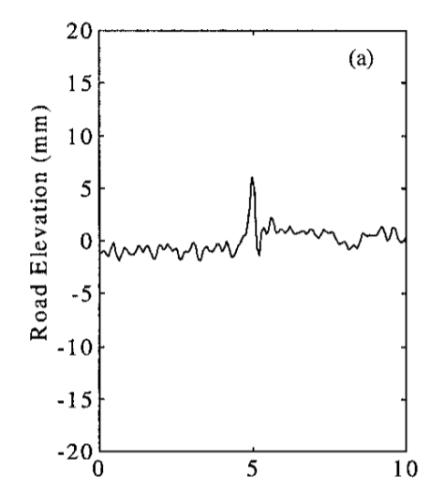

**Fig. 1.** Rope elevation as function of distance. An example graph for a road section. [1]

* 1. Random distributions of road profiles

In paper [5], it is shown that probability distribution (PD) of road elevation of transient free road sections sets in Gaussian distribution. The transient free part or in other words stationary parts of road profile represents road surface roughness. However, road profiles may vary on contact surface of each measurement which may cause statistical irregularities in the data. In the paper, road vertical displacements for road surface are derived as root mean square (RMS) for each measurement segment. In Fig. **2**, it can be seen that RMS spatial acceleration (double derivative of road profile) of a steady state road section sets in Gaussian distribution.

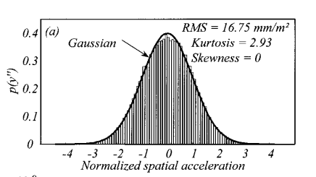

**Fig. 2.** Probability distribution for typical transient-free road section.

Then as mentioned earlier, the reality is that the road profiles have transient parts. Thus, the PD of this is only valid if data is stationary. Further analysis of transient parts, especially RMS values fits Rayleigh distribution. [5] The Rayleigh distribution is defined as

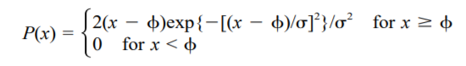

(1)

, where P(x) = probability of the signal at RMS level x; x =RMS level; ϕ = offset level; and s = standard deviation of the RMS level. [5] Fig.3 displays Rayleigh distribution of two types of road profiles.

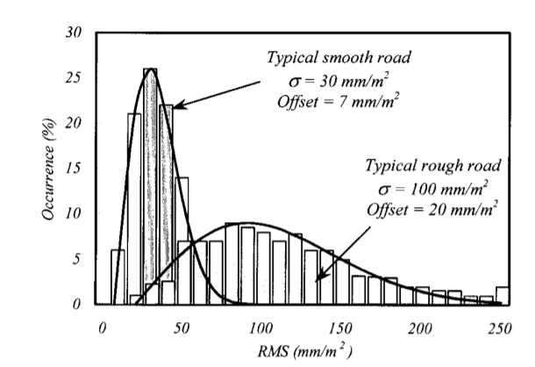

**Fig.3.** distribution of two typical road sections with best Rayleigh fitting offsets. [5]

So, in order to estimate amplitude of loading on a semi-active suspension system of a vehicle, road type must be defined. The definition of road type can be obtained the most accurately by measuring sections of an analyzed road. The measurements of road profile can be done in different methods. For our application case, our data can be gathered by using accelerometers in the different axles of the vehicle. It can be practical to guide us by the test method defined by the ASTM Standard E1364-95 [2], that specifies steps and procedure to determine road roughness index, used to calibrate response-type roughness-measuring systems. It establishes that the measured data points have a sample frequency of 0.25 m per 1 m [3].

The case of application can be a 100-meter road sections, where the vehicle drives repeated times at velocities of 50, 60 and 70 km/h with sampling frequencies of 500 and 1000 Hz, over the corresponding time span associated to travel that distance at the different speeds (so 7.2, 6 and 5.14 seconds). In our case, changing the time span would mean changing the speed of the vehicle (or changing the length of the road, but in practical terms, keeping the road section to analyze always the same is best). The figures below show, according to the study [3] the expected effect of changing the frequency samples and time spans for the cases of 20 and 40 km/h. It states that it is advisable to carry out such studies on a constant speed of around 60 km/h for roads with asphalt pavement. It should be also noted that an adequate speed value may be increased or decreased depending on the class of the road pavement.

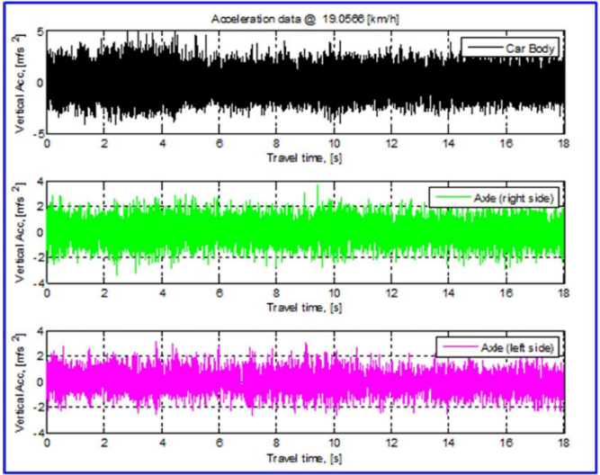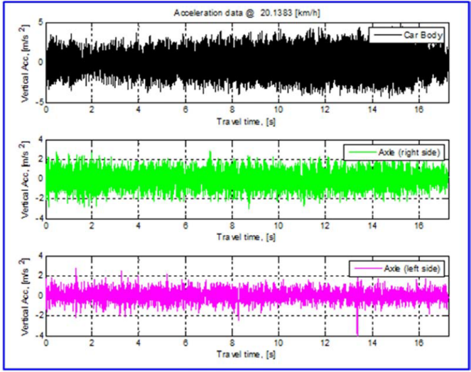

Fig. 2: Raw acceleration data collected at 20 km/h with sampling frequencies of 500 Hz and 1000 Hz [3]

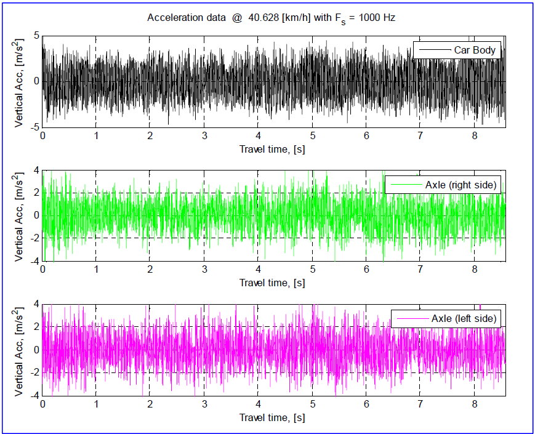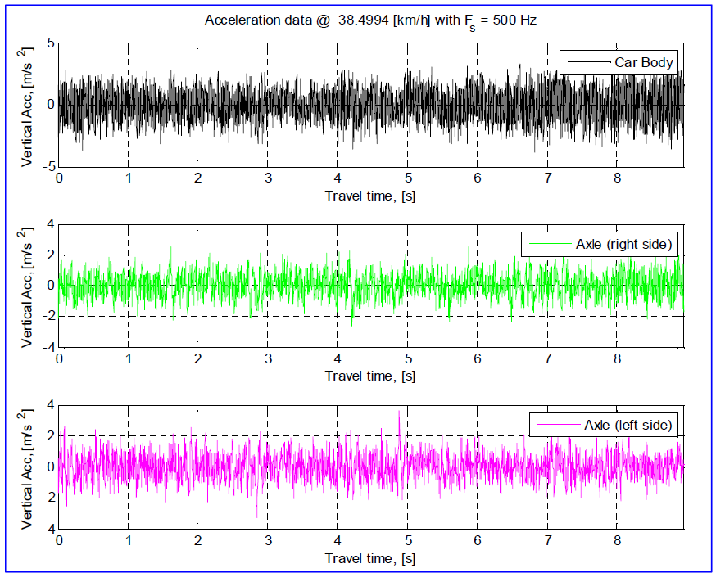

Fig. 3: Raw acceleration data collected at 40 km/h with sampling frequencies of 500 Hz and 1000 Hz [3]

1. Road profile relevant to specific engineering and its analysis
   1. Load spectrums relevant to semi-active damper suspension system

In order to describe random response by applying RAO, power spectral density (PSD) of loading must be derived. In addition, when PSD is used as the sole description of road surfaces, the signal is assumed to have gaussian distribution and transient parts are lost. [1] According to paper [7], the simplest analytical description of PSD is

(2)

where [rad/m] is the angular spatial frequency , where L is wavelength, C is unevenness index and w is waviness. For this report, following parameters are chosen from the paper [7]

* A mean value for C chosen as 0.336 [10^-6 rad m]
* The waviness ranges from 1.5 to 3.5 with the most typical value as w = 2.
* ISO 8608 wavelengths from wavelength band 0.3054 m to 90.9 m or spatial frequency range 0.011 cycles/m to 2.83 cycles/m
  1. Response for random loading based on RAO

Since response amplitude operator (RAO) is a transfer function, we can compute it and then multiply the last input Sxx to obtain the response of the vehicle.

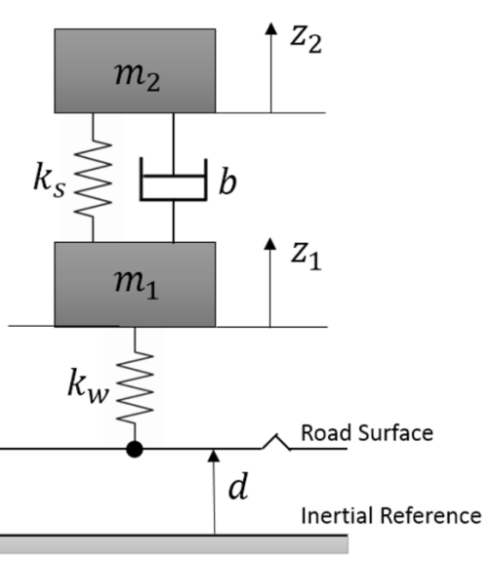

Figure2 Car suspension system

From the figure1[3], we can build the dynamic equations of the model are given by:

the output of system of z1 and z2, the input of system is d, m2, m1, ks, kw, b which are the distance between road profile and inertial reference constants of masses, springs and coefficient of damper.

(3)

(4)

And then set the state-space formula,

(5)

Where,

(6)

And get the transfer function which is H(w) and using formula 6 below calculate response for random loading:

(7)

Figures 4 to 6 display response of damping system, random loading and response of the whole suspension system under random loading.

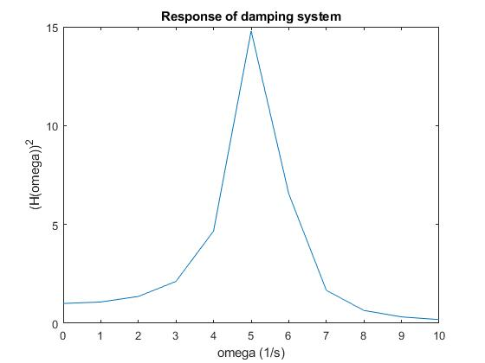

Fig. 4: Response of vehicle damping system squared

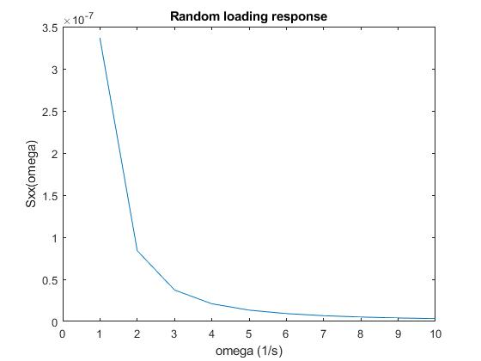

Fig. 5: Random loading response

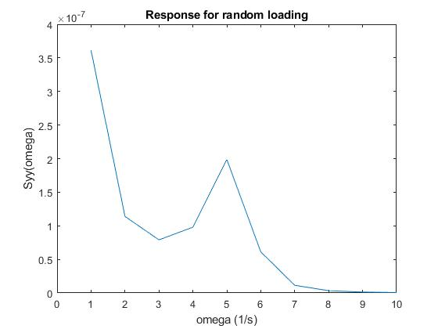

Fig. 6: Response of the system for random loading

* 1. The band’s type of semi-damper suspension system

In order to transform the type of band, we could decrease the sampling frequency if the signals of band from sensors are broad band. Once the sampling frequency is shortened, in comparison with the original state, we could get some narrow-banded signals.

Additionally, through referring to literatures, the formation of narrow band is normally created by superposition of several short bands from sensors. That is to say, if we want to get a narrow-banded signal, we can do the reverse computation. In articles, researchers put forward some algorithms to get the broad band when a series of narrow bands are provided [6]. Because of the linearized correlation among signals, a reliable method to get narrow band is that using the final value of broad band to filter some irrelevant frequencies, a band with low frequency can be computed to meet the requirement.

1. Sensor application and discussion about extreme events
   1. Sensors to reflect the random excitations and responses

In compared with different strategies to measuring the excitations and responses, here, displacement sensor, accelerometers and force sensor are needed.

Firstly, we can use displacement sensor, such as linear variable differential transformer (LVDT), for measuring displacement of body mass, wheel mass and displacement of tyre related to the road profile. Almost the same variable we can measure using accelerometers, specifically we can measure acceleration of body mass and wheel mass. We should also place in a force sensor in order to get feedback from the semi-active feedback and to get an option to control that damping force by changing the level of electrical voltage in the damper.

* 1. Extreme event relevant to semi-damper suspension system

The study “Specification of Obstacles in the Longitudinal Road Profile by Median Filtering” [8] is part of the Journal of Transportation Engineering-ASCE 2011 indexed in Scopus. It describes how the median filtering method can be a productive choice when it comes to separating random and nonrandom parts of longitudinal road unevenness. In the case of large obstacles present in roads, being this a case of an extreme event, stochastic laws cannot be applied, so they should be treated separately. About 23,400 records of road profiles gathered from the Long-Term Pavement Performance (LTPP) program were processed from which 5,036 profiles displayed obstacles higher than 0.3 cm. A total number of 16,590 obstacles were detected. Statistical processing of all these profiles to distinguish between asphalt concrete and portland cement concrete road surfaces and between bumps and potholes identified that 71% of all obstacles belong to the asphalt concrete and pothole combination. [8].

**Reference**

[1] Bruscella, B., Rouillard, V. and Sek, M., 1999. Analysis of road surface profiles. Journal of Transportation Engineering, 125(1), pp.55-59.

[2] ASTM Standard E1364-95 (Re-approved-2000). Standard Test for method for measuring road roughness by static level method. ASTM International, 100 Bar Harbor Drive, West Conshohocken, PA, USA.

[3] Sulaymon Eshkabilov, Abduvokhid Yunusov, Measuring and Assessing Road Profile by Employing Accelerometers and IRI Assessment Tools, *American Journal of Traffic and Transportation Engineering*. Vol. 3, No. 2, 2018, pp. 24-40. doi: 10.11648/j.ajtte.20180302.12

[4] Zhang L , Zhou W , Wen-Liang L I . A Method of Load Spectrum Construction for Big Operation Vehicle Based on User Goal[C]// 0.

[5] Rouillard, V., Sek, M.A. and Bruscella, B., 2001. Simulation of road surface profiles. Journal of transportation engineering, 127(3), pp.247-253.

[6] Liang S . Narrowband to broadband conversions of land surface albedo I[J]. Remote Sensing of Environment, 2001, 76(2):213-238.

[7] Kropáč, O. and Múčka, P., 2008. Deterioration model of longitudinal road unevenness based on its power spectral density indices. Road materials and pavement design, 9(3), pp.389-420.

[8] Kropáč, O. and Múčka, P., 2011. Specification of Obstacles in the Longitudinal Road Profile by Median Filtering. Journal of Transportation Engineering-ASCE, 2011, 137(3): 214-226